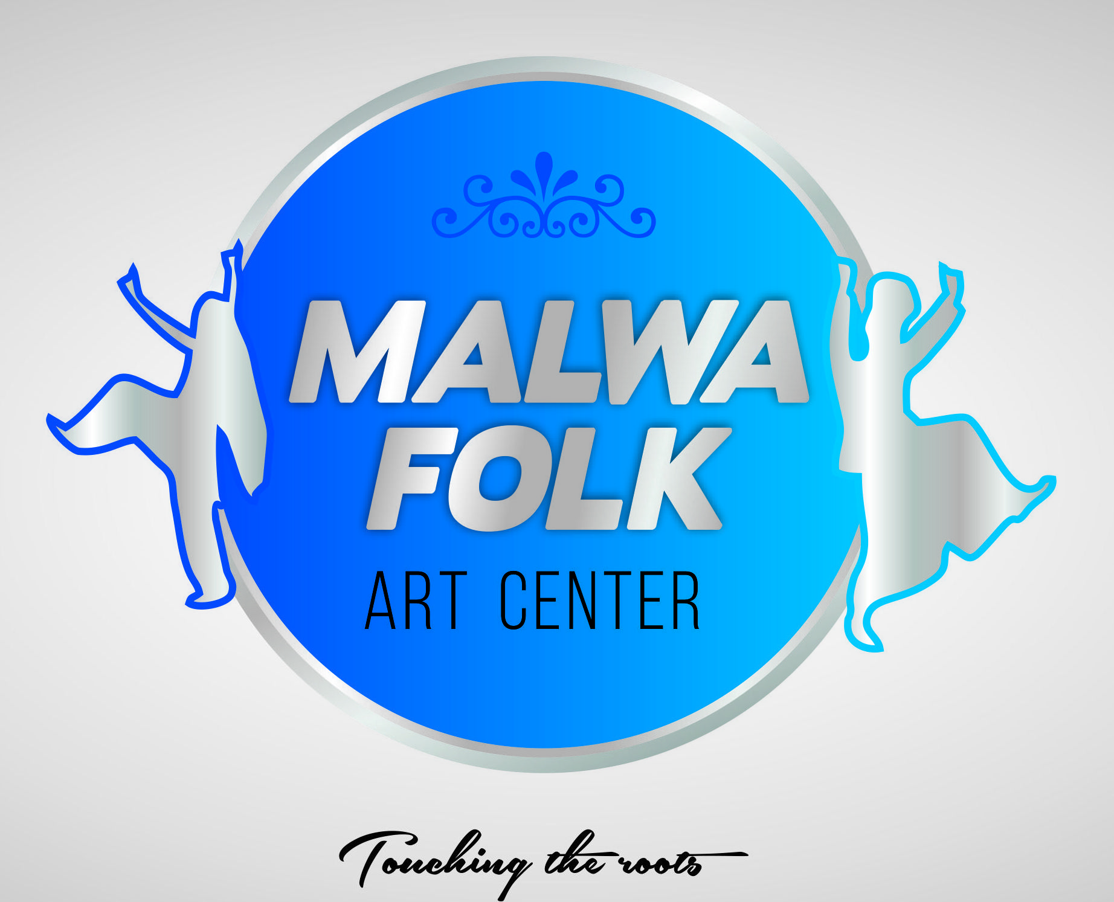 MALWA FOLK ART CENTER
Touching the roots
Student Name : ________________________________
Age:___________ DOB_______________ GENDER __M/F_______
Address: _________________________________
Cell: __________________________(to be added in whatsapp group)
Email: ______________________________________________________
Class Enrolling in( Days of the week)___________________________________________
Current Level: -----------------------------------------------------------
Family Doctor's Name and Phone No. -----------------------------------------------
Care card number ----------------------------------------------------------------------
Monthly fee (in advance)- DUE FIRST WEEK OF MONTH STRICTLY (Late fee applied $ 10 after 7th of each month)
4- Sessions/Month - $ 40
8- Sessions/Month - $ 70
12- Sessions/ Month - $ 95
- FEE NON-REFUNDABLE
- Cash and cheques (post-dated) are acceptable.
- One Month prior notice is required if you wish to discontinue at any point to avoid payment for that month.
- Institute will not be held responsible for any injury to kids happened while dance sessions or in academy. Immediate first aid will be provided.
INSTRUCTION: (Strictly to follow)

- If the student or any of the members of your family is sick or have symptoms or in quarantine, please do not send the child and inform us.
- Eatables are not allowed strictly.
- Strictly drop-offs for students. No one is allowed to sit inside the academy during session.
- Parents should arrive 15 minutes prior before the class ends as the preparation for the next class will be required to be done and to avoid the clash of students.
- No complimentary class will be provided if you missed the class.

Participant's Signature: Date: _________________________________________________________________
(Parent or Guardian Name and Signature if under 18 Years of age)
Photo/ Video Release Waiver

I acknowledge and consent to allow the Malwa Folk Art Center to click photos, do videography, use photos and/ or video of my child/myself in publications (flyers/ brochures), advertisements (online social media etc.), academy annual events or studio website.

I understand no financial compensation will be for use of these photos/videos.

_____________________________________________________________
Name of the Child/Adult

Signature (Parent/Guardian of minors)

Date

